**Document for Smart Task Manager**

● Define the tech stack you’d use (e.g., Java/Kotlin/Node.js/React/PHP).

I have used MERN Stack in this project, I haven’t used Mongo DB since I didn’t want to complex things.

● Explain why you picked that stack.

This is because I have a little expertise in the MERN Stack through a course that I am learning of Full-Stack Open from Open University of Helsinki (Which also uses MERN-Stack).

● Share a high-level architecture diagram (can be hand-drawn or in a tool).

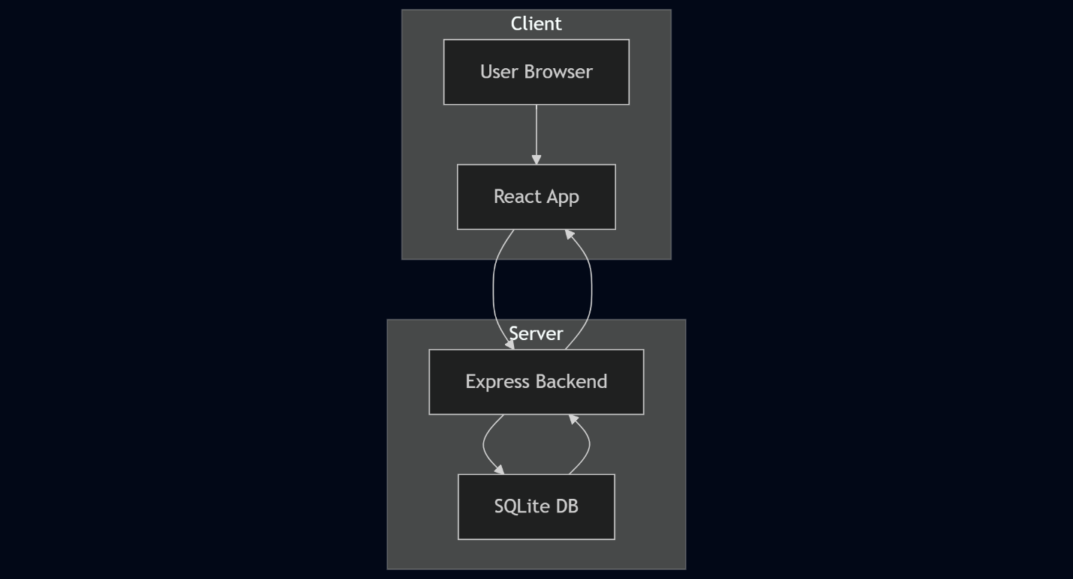

● Describe your database schema.

